Subject:
Surprise Monthly Letter - Ken is 90!
From:
"Ken Jefferson" <ken.jefferson@sympatico.ca>
Date:
3/21/2016, 4:54 PM

To:
"Amanda Thum" <chargingbird@gmail.com>, "Andrea Champagne" <andrea@andreachampagne.com>, "Ann DeYoung" <radeyo@aol.com>, "Ann Parker" <anniecleve@gmail.com>, "Anne Dawson" <dawsoanne@gmail.com>, "Art Ward" <awgamut@aol.com>, "Barbara Arley" <barbaraarley@comcast.net>, "Barbara Baker" <barbarajune@sympatico.ca>, "Bob Perry" <rjp@lrandolphamis.com>, "Carol & Bruce" <carola@nc.rr.com>, "Carol Anyango" <africanpot@yahoo.co.uk>, "Chuck Parker" <camelotcrp@aol.com>, "Colin Peck" <colinpsf@gmail.com>, "Danny Peck" <dwpeck@gmail.com>, "Dave Adams" <daveadams@digistep.com>, "Diane Dunn" <d.dunn@earthlink.net>, "Gail Dawson" <gail.at.home@rogers.com>, "Gail Jacobs" <two4foxrun@yahoo.com>, "Gerry Bennett" <gerry_bennett@yahoo.com>, "Graham Baker" <grbaker@sympatico.ca>, "Heidi Jefferson" <mamallamavt@gmail.com>, "Jane Dawson" <janekdawson839@gmail.com>, "Jane Perry" <perryjane25@gmail.com>, "KC McDevitt" <kc.mcdevitt@hotmail.com>, "Keith Dawson" <kdawson@avvasi.com>, "Keith Thorslund" <kthorslund@anvilinc.com>, "Ken Jefferson" <ken.jefferson@sympatico.ca>, "Ken McLain" <kdmclain@netzero.net>, "Linda Jefferson" <ljeffers10@gmail.com>, "Linda McDevitt" <lamcdev@hotmail.com>, "Lynda Baker-Thorslund" <lynda.baker-thorslund@ocdsb.ca>, "Mary Bowman" <marybowman@bell.net>, "Matt Jefferson" <papamattic@gmail.com>, "Morgaen Munoz" <morgaenmunoz@gmail.com>, "Myr & Johm" <elvenmyr@yahoo.com>, "Nancy Jefferson" <njeff@att.net>, "Norm McDevitt" <n.mcdevitt@bell.net>, "Patti Labounty" <pattilabounty@gmail.com>, "Peter Bowman" <snoman@bell.net>, "Peter Walsh" <pmhwalsh@shaw.ca>, "Sara Jefferson" <sara.jefferson02@gmail.com>, "Sara Peck" <sarajpeck@yahoo.com>, "Sue McCleskey" <smccleskey@ctgconsult.com>, "Vaughan Lund" <vlund@coop-tech.com>, "Wilene Brown" <willene.brown@gmail.com>

Ottawa Outlook, nee North Hero News and World Review …. ……. Mostly stuff no one else would print. Outlk16wc1 (2016 Letter #1)

SURPRISE.

Hi all, …
Hope this much delayed “Monthly Letter” is not too much of a shock. , …

We, (Lucille and Ken) are both doing fine and are well taken care of at the Carlingwood Retirement Home. As we’ve said before, about the only thing we’re allowed to do is brush our own teeth. (Yes, we still have some, teeth, that is.) In case you don’t believe us, we’ve attached some pictures as proof.

Good Grief, … come the Vernal Equinox (3/21) Ken will be 90!Neither family history nor life he’s led gave a clue to this impending longevity. Boy, … be it known that we are one aging couple that is doing fine, no wheelchairs, walkers, no canes, Kinda tempting to go skipping into the dining room hand-in-hand.one of these days.

As for keeping up with the world, we aren’t.We subscribe to a good newspaper, The Toronto Globe & Mail, but comprehend hardly anything in it. Negative interest rates, … Near East mess, … Terrorist attacks, … Canadian politics, … American Presidential campaigns, … Phew! That Republican rich guy reminds us of Archie Bunker. Think we’ll send in a donation to that pretty normal from Vermont. Like to see him stay the course. Nuff for now.

Will try to resume some sort of semblance of a “Monthly Letter” if things continue to go well.

Lucille & Ken, regards to all,

Tll next month, Lucille & Ken.
Carlingwood Retirement Community
200 Lockhart Ave, Apt 411 Ottawa ON k2a4C6 613-693-0600
Ken Jefferson
ken.jefferson@sympatico.ca
S51011CB202033_c_8.1.jpg
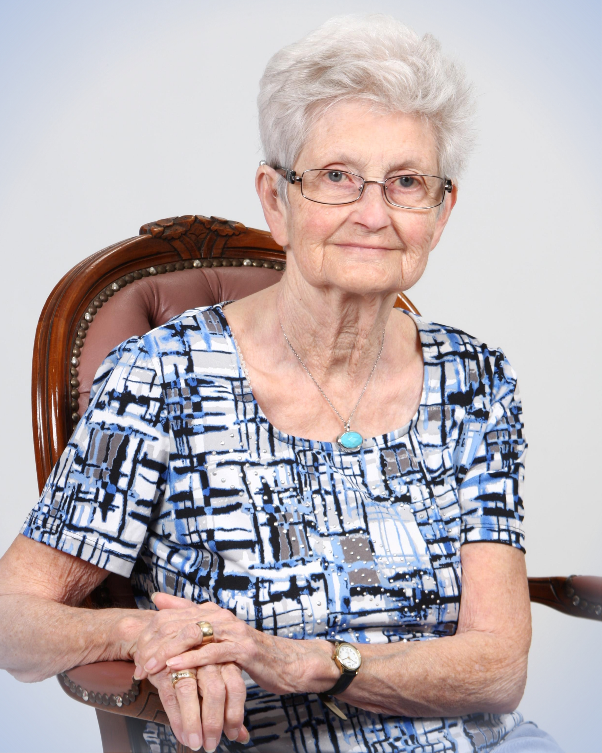
S51011CB202033_p_4.jpg
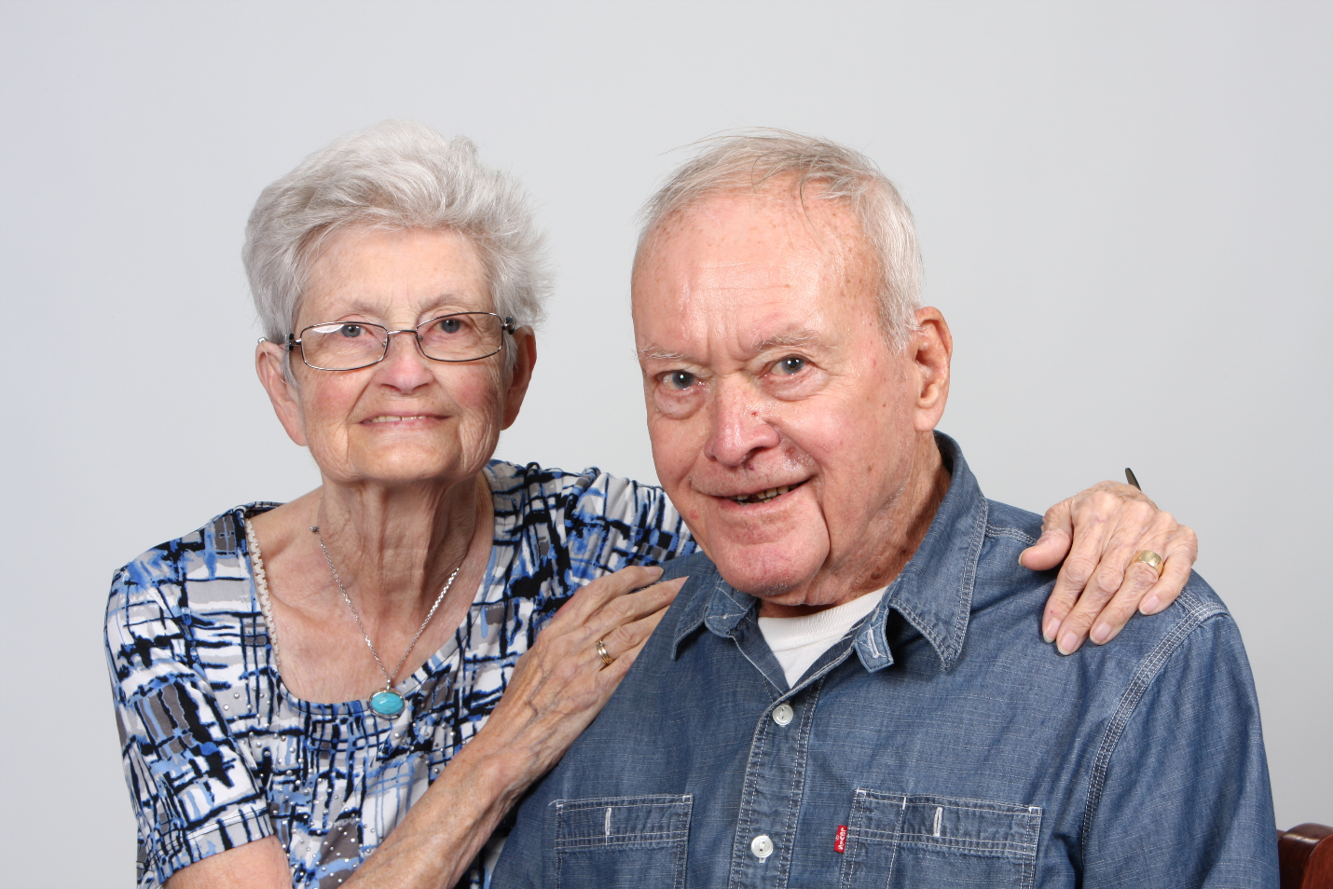
Attachments:
S51011CB202033_c_8.1.jpg | 2.9 MB
S51011CB202033_p_4.jpg | 3.5 MB

