Subject:
December Monthly Letter
From:
Ken Jefferson <ken.jefferson@sympatico.ca>
Date:
12/2/2014, 4:14 PM

To:
Amanda Thum <chargingbird@gmail.com>, Ann DeYoung <radeyo@aol.com>, Ann Parker <anniecleve@gmail.com>, Anne Dawson <dawsoanne@gmail.com>, Art Ward <awgamut@aol.com>, Barbara Arley <barbaraarley@comcast.net>, Barbara Baker <barbarajune@sympatico.ca>, Bob Perry <rjp@lrandolphamis.com>, Carol and Bruce <carola@nc.rr.com>, Carol Anyango Okumu <africanpot@yahoo.co.uk>, Carole Peck <carolepeck13@aol.com>, Chuck Parker <camelotcrp@aol.com>, Colin Peck <colinpsf@gmail.com>, Danny Peck <dwpeck@gmail.com>, Dave Adams <daveadams@digistep.com>, Diane Dunn <d.dunn@earthlink.net>, Gail Jacobs <two4foxrun@yahoo.com>, Gerry Bennett <gerry_bennett@yahoo.com>, Graham Baker <grbaker@sympatico.ca>, Heidi Jefferson <mamallamavt@gmail.com>, Jane Dawson <janekdawson839@gmail.com>, Jane Perry <perryjane25@gmail.com>, KC McDevitt <kc.mcdevitt@hotmail.com>, Keith Dawson <kdawson@avvasi.com>, Keith Thorslund <kthorslund@anvilinc.com>, Ken Jefferson <ken.jefferson@sympatico.ca>, Linda Jefferson <ljeffers10@gmail.com>, Linda McDevitt <linda.mcdevitt@sympatico.ca>, Lynda Baker-Thorslund <lynda.baker-thorslund@ocdsb.ca>, Mary Bowman <marybowman@bell.net>, Matt Jefferson <papamattic@gmail.com>, Morgaen Munoz <morgaenmunoz@gmail.com>, Myr and John <elvenmyr@yahoo.com>, Nancy Jefferson <njeff@att.net>, Norm McDevitt <n.mcdevitt@bell.net>, Patti Labounty <pattilabounty@gmail.com>, Peter Bowman <snoman@bell.net>, Peter Walsh <pmhwalsh@shaw.ca>, Sara Jefferson <sara.jefferson02@gmail.com>, Sara Peck <sarajpeck@yahoo.com>, Sue McCleskey <smccleskey@ctgconsult.com>, Theresa Burke <tburke8007@rogers.com>, Vaughan Lund <vlund@coop-tech.com>, Wilene Brown <willene.brown@gmail.com>

Ottawa Outlook, nee North Hero News and World Review …. ……. Mostly stuff no one else would print. Outlk14wc12 (2014 Letter # 12)
SNOW TIRES

As most are aware, we replaced our Saturn with a Toyota Echo. As some might not know, Canada is very hung up on snow tires, perhaps best illustrated with a little imagination. Lucille and Ken are out for a winter drive in the Echo which Ken has never put snow tires on. They are ramed from behind by a speedster doing 80. Result? Ken’s fault cause his car doesn’t have snow tires. Motto: Have snow Tires.
Now, … we had the snow tires from the Saturn, in our own garage, … mounted on their own rims, but Saturn and Echo have different number of lugs. Tire size should be OK though. Would just need rims.

Well, we’ll just get all the pieces together and them over to our local mechanics, Bob Peters and Bob Peters by name. Norm McDevitt volunteers.
Monday, …the Echo is in the basement of the Retirment Home, Norm walks to the Retirement Home, 1 hour. Norm gets Echo key from Ken, drives Echo to Ken’s garage and loads the Saturn snow tires in the Echo. Norm calls Peter’s Garage and explains the situation, They say to bring the car in on early Wednesday. Norm takes it in on Tuesday night and parks it behind the Garage. Wednesday, a super busy day at Peter’s. Retirerees had no dire need for their car as Peters well knew. Echo sits out back. Thursday, Bob Peter’s ready to do operation Snow Tire. Goes out and looks at the Echo. Takes second look. The next sentence emanating from both Peters ended the Snow Tire caper.
“This car already has snow tires!”
At his point, Bob Peters and Bob Peters both think Ken and Norm are a couple of Ninnies. Which is in perfect agreement with what they think themselves.
(Hey Jim Peck … ever get two dumbells like this?)

Time to change the subject. Lucille’s eye surgery has come out wonderfully. She no longer needs a corrective lens in the eye operated on. We’re going to get the other one done in the coming year. Month 3 in the retirement home and still going well. Ken glad they at least allow him to brush his own teeth.

The retirees Christmas picture is attached.

Till next month, Lucille and Ken.
Carlingwood Retirement Community
200 Lockhart Ave, Apt 411
Ottawa ON k2a4C6
613-693-0600
Ken Jefferson
ken.jefferson@sympatico.ca
Xmas 2014.JPG
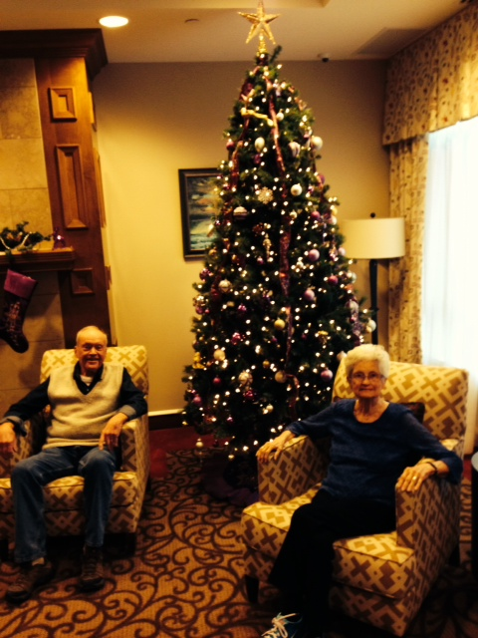
Attachments:
Xmas 2014.JPG | 143 KB

