Subject:
November Letter
From:
Ken Jefferson <ken.jefferson@sympatico.ca>
Date:
11/1/2014, 9:05 AM

To:
"Amanda Thum" <chargingbird@gmail.com>, "Andrea Champagne" <andrea@andreachampagne.com>, "Ann DeYoung" <radeyo@aol.com>, "Ann Parker" <anniecleve@gmail.com>, "Anne Dawson" <dawsoanne@gmail.com>, "Art Ward" <awgamut@aol.com>, "Barbara Arley" <barbaraarley@comcast.net>, "Barbara Baker" <barbarajune@sympatico.ca>, "Bob Perry" <rjp@lrandolphamis.com>, "Carol & Bruce" <carola@nc.rr.com>, "Carol Anyango" <africanpot@yahoo.co.uk>, "Carole Peck" <carolepeck13@aol.com>, "Chuck Parker" <camelotcrp@aol.com>, "Colin Peck" <colinpsf@gmail.com>, "Danny Peck" <dwpeck@gmail.com>, "Diane Dunn" <d.dunn@earthlink.net>, "Gail Jacobs" <two4foxrun@yahoo.com>, "Gerry Bennett" <gerry_bennett@yahoo.com>, "Graham Baker" <grbaker@sympatico.ca>, "Heidi Jefferson" <mamallamavt@gmail.com>, "Jane Dawson" <janekdawson839@gmail.com>, "Jane Perry" <perryjane25@gmail.com>, "KC McDevitt" <kc.mcdevitt@hotmail.com>, "Keith Dawson" <kdawson@avvasi.com>, "Ken Jefferson" <ken.jefferson@sympatico.ca>, "Ken McLain" <kdmclain@netzero.net>, "Linda Jefferson" <ljeffers10@gmail.com>, "Linda McDevitt" <lamcdev@hotmail.com>, "Mary Bowman" <marybowman@bell.net>, "Matt Jefferson" <papamattic@gmail.com>, "Morgaen Munoz" <morgaenmunoz@gmail.com>, "Myr & Johm" <elvenmyr@yahoo.com>, "Nancy Jefferson" <njeff@att.net>, "Norm McDevitt" <n.mcdevitt@bell.net>, "Patti Labounty" <pattilabounty@gmail.com>, "Peter Bowman" <snoman@bell.net>, "Peter Walsh" <pmhwalsh@shaw.ca>, "Sara Jefferson" <sara.jefferson02@gmail.com>, "Sara Peck" <sarajpeck@yahoo.com>, "Sue McCleskey" <smccleskey@ctgconsult.com>, "Vaughan Lund" <vlund@coop-tech.com>, "Wilene Brown" <willene.brown@gmail.com>

Ottawa Outlook, nee North Hero News and World Review …. ……. Mostly stuff no one else would print. Outlk14wc11 (2014 Letter # 11)

THE MONTH THAT WAS.
“How do we begin, … to tell the story” of the busy month that was …
Let’s see. We had a car die. We replaced it. We got a bike. We wiped out on it. Lucille had an eye operation. This has gone well. We moved into a Retirement Community for a one month trial stay. This is in progress.
Kind of sad saying goodbye to the old 2002 Saturn. This car was brother David’s last, and we really liked driving it. We are of the opinion that it died of Alzheimer Disease. There were two computers aboard and they seemed to forget how to talk to one another. There were imagined Security Risks, the transmission at times refused to leave park, the gages looked like they were having a Barn Dance and one never knew what delightful weirdness would pop up next. Trace down the cause? We were told this would be expensive and success questionable. Time to say Goodbye We replaced it with a 2002 Toyoto Echo, the most un-computerized car we could find. It is running fine so far.
Lucille’s eye operation and the trial Retirement Community stay sort of go hand in hand. Pre-op and post-op care was rather involved. Involved and still on-going, (three different drops 4 times a day). This has been professionally handled by the nurses at the home and her surgeon is very pleased with Lucille’s recovery progress. Needless to say, so are we. Apart from our lack of wheel chairs, walkers or canes we seem to fit right in here. White hair and all. Course in all honesty, everyone else looks so old. The food is excellent, the place is quiet and we are adjusting to the fact that just about everything is done for us. I’ve attached a photograph of us at breakfast of Belgian waffles and bacon this morning. Interestingly enough ,… got to mention my bike during the the physical/mental evaluation interview. One question: “Have you had any falls lately?”
Answer:
“I had a duzy, … wiped out on my bike.”
Probably shouldn’t brag, but we both sailed thru that interview with flying colors. Ah, … almost time for dinner, Beef tips in red wine sauce with all the accoutrements.

Til next month, Lucille and Ken.
Carlingwood Retirement Community
200 Lockhart Ave, Apt 411
Ottawa ON K2A4C6
613-693-0600

Ken Jefferson
ken.jefferson@sympatico.ca
photo.JPG
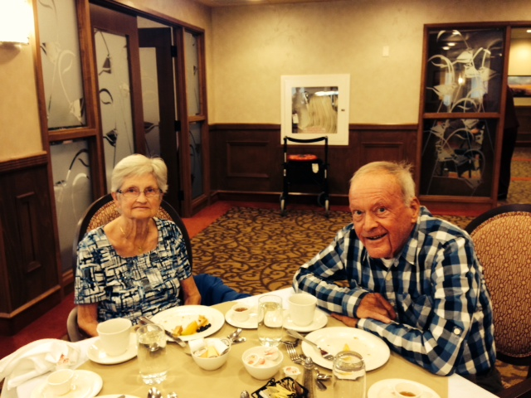
Attachments:
photo.JPG | 146 KB

